Index

|  |  |  |
| --- | --- | --- |
| S.No | Exp.No | Pg.No |
| 1 | 1 | 1 |
|  |  |  |
|  |  |  |
|  |  |  |
|  |  |  |
|  |  |  |
|  |  |  |
|  |  |  |
|  |  |  |
|  |  |  |
|  |  |  |
|  |  |  |
|  |  |  |
|  |  |  |
|  |  |  |
|  |  |  |
|  |  |  |
|  |  |  |
|  |  |  |

1. Create a webpage using ordered list and unordered list

Code:

<html>

<head>

<title>My first web page</title>

</head>

<body>

<h1>This is a heading</h1>

<h2>This is also a heading</h2>

<h3>This is also a heading</h3>

<h4>This is also a heading</h4>

<h5>This is also a heading</h5>

<h6>This is also a heading</h6>

<p>This is a paragraph</p>

<h1>This is an unordered list</h1>

<ul>

<li>Coffee</li>

<li>Tea</li>

<li>Milk</li>

</ul>

<h1>This is an ordered list</h1>

<ol>

<li>Coffee</li>

<li>Tea</li>

<li>Milk</li>

</ol>

</body>

</html>

Output:

1. Create a webpage using description list

Code:

<html>

<head>

<title>

un description list

</title>

</head>

<body>

<h1>

This is an description list

</h1>

<dl>

<dt>Coffee</dt>

<dd>- Black hot drink</dd>

<dt>Milk</dt>

<dd>-white cold drink</dd>

</dl>

</body>

</html>

Output:

1. Create a webpage using about yourself

Code:

<html>

<head>

<title>About me</title>

</head>

<body>

<h1><i>About me</i></h1>

<h3>This is an unordered list</h3>

<ul>

<li><h2>Name :</h2><p> <u>Jaden</u></p></li>

<li><h2>DOB :</h2><p> 10 <sup>th</sup> September, 2005</p></li>

<li><h2>Age :</h2><p> 19 </p></li>

<li><h2>Sports :</h2> <strong>Football,</strong> <del>Cricket,</del> <ins>Basketball,</ins> <small>Volleyball</small> </li>

<li><h2>Age :</h2><p> 19 </p></li>

</ul>

<dl>

<dt><h3>School</h3></dt>

<dd><ol><li>Bishop Cotton <em>Boy's</em> School</li><li>Vibgyor <mark>High</mark></li></ol></dd>

<dt><h3>College</h3></dt>

<dd><ul><li>Amity University</li></ul></dd>

</dl>

</body>

</html>

Output:

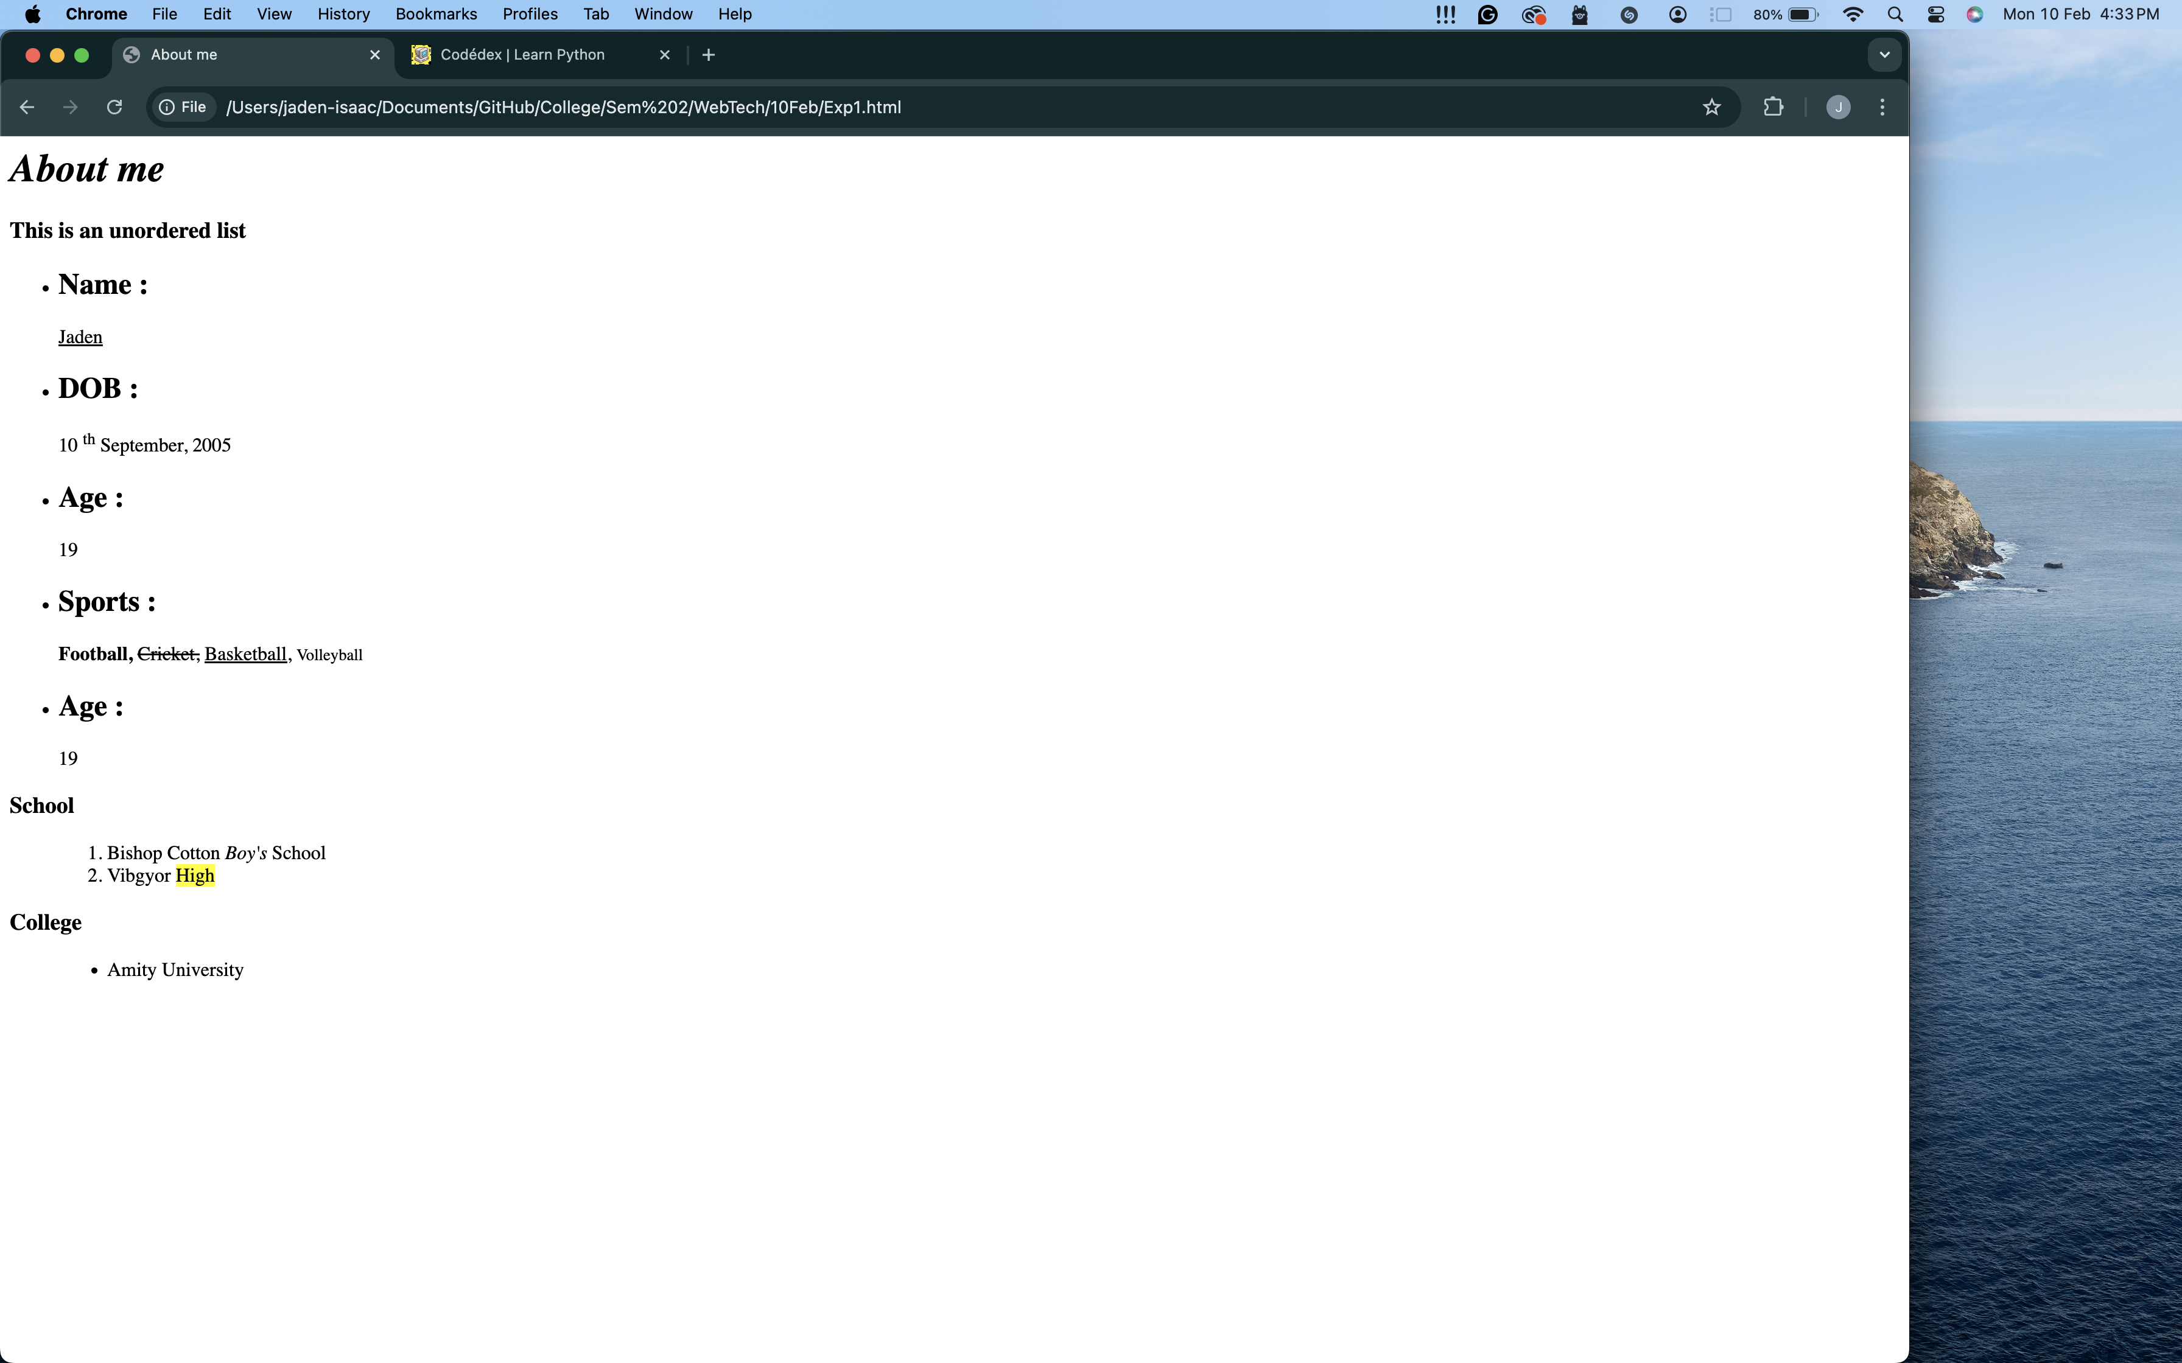

1. Create a webpage using about yourself

Code:

<html>

<head>

<title>

Table

</title>

</head>

<body>

<h1>

This is a table

</h1>

<table border="10" style="width: 50%;">

<tr style="height: 50px;">

<th></th>

<th colspan="2">Day</th>

<th>Month</th>

<th>Year</th>

</tr>

<tr style="height: 50px;">

<th rowspan="2">Fun Days</th>

<td>monday</td>

<td>10</td>

<td>feb</td>

<td>2025</td>

</tr>

<tr style="height: 50px;">

<td>friday</td>

<td>14</td>

<td>feb</td>

<td>2025</td>

</tr>

<tr style="height: 50px;">

<th rowspan="3">Boring Days</th>

<td>tuesday</td>

<td>11</td>

<td>feb</td>

<td>2025</td>

</tr>

<tr style="height: 50px;">

<td>wednesday</td>

<td>12</td>

<td>feb</td>

<td>2025</td>

</tr>

<tr style="height: 50px;">

<td>thursday</td>

<td>13</td>

<td>feb</td>

<td>2025</td>

</tr>

</table>

</body>

</html>

Output: